Unit Visiting

Responsibility for new member screening belongs to the District Commissioner and the Area Commissioner.
Every woman participating in Unit activities must be properly screened by the District Commissioner. This work needs to be completed before she starts participating
Every girl attending Unit activities must also be registered before she attends more than 1 meeting.
District Commissioners must visit Units at least 2 times each Guiding year to ensure that all participants are properly screened. 100% compliance in all Units in your District is essential. (Ask your AC about a delegate to assist you with this process).
Visits must happen by November 15 and March 15 of every Guiding year. The attached document must be submitted to the AC for each Unit by November 15 (to ensure iMIS updated prior to Dec 1st count) and March 30.
These are the Screening steps:
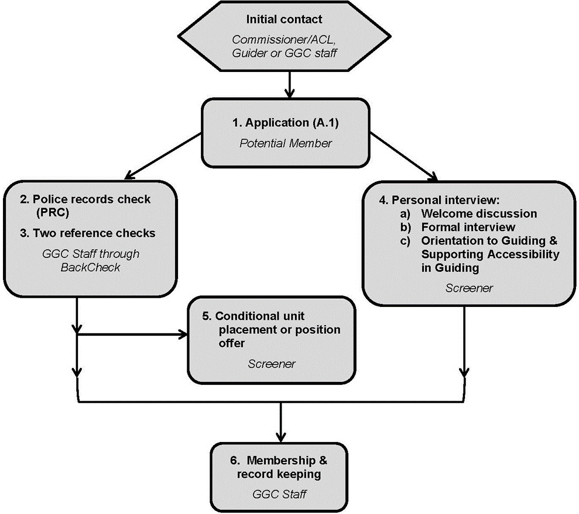

Unit Visit

Unit Name_____________________________________________ Code of Conduct

Contact Guider____________________________iMIS number______________
Other Guiders:
- __________________________________iMIS number______________
- __________________________________iMIS number______________
- __________________________________iMIS number______________
- __________________________________iMIS number______________
- __________________________________iMIS number______________
- __________________________________iMIS number______________
Other adults________________________________Role_____________________
___________________________________________________________________

Before going to the meeting, print your roster and check the girls on the roster with the Contact Guider, during the Unit visit. Are there missing girls?
# of Girls on roster________________________
# of Girls attending meeting________________

Date of visit______________________________
District Commissioner or approved delegate (signature)_________________________________

