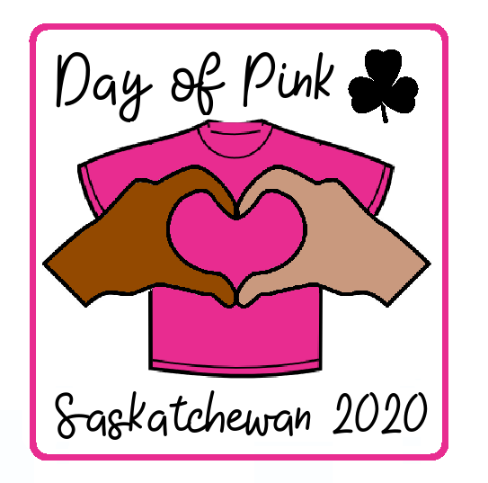
Day of Pink Saskatchewan Campfire 2020
Join with Girl Guides across Saskatchewan on April 8th, 2020 to show support for Day of Pink by leading this campfire in your community.

Land Acknowledgment
It is important during events like these to acknowledge the history of the lands that we are meeting on today. Please take time before your campfire to learn about which treaty your community is a part of and the people whose ancestral homeland it is.
We would like to begin today by acknowledging that we are meeting on (insert Treaty if there is one) and the traditional, and ancestral land that has been inhabited by (insert Nation or Peoples names).
Treaty 4 and Treaty 6 territories taken from the Saskatchewan School Boards:
(Regina/Moose Jaw/Swift Current/Maple Creek/Yorkton/Melville) is located on Treaty 4 territory, the original lands of the Cree, Ojibwe (OJIB-WĒ), Saulteaux (SO-TO), Dakota, Nakota, Lakota, and on the homeland of the Métis Nation.
(Saskatoon/Prince Albert/North Battleford/Lloydminster/Meadow Lake) is located on Treaty 6 territory which encompasses the traditional territories of numerous First Nations, including Cree, Dene (DEN-Ē), Nakota, Saulteaux (SO-TO), and Ojibwe (OJIB-WĒ) and the homeland of the Métis Nation.
We're grateful for the opportunity to meet here and we thank all the generations of people who have taken care of this land and recognize and deeply appreciate their historic connection to this place. Especially as we are here to stand up against discrimination, we must think about our mistakes of the past reconciliation to truly be inclusive of everyone.

Opening
We are meeting today and wearing pink in solidarity with the LGBTQ+ community and all marginalized groups to stand up against bullying and discrimination. Girl Guides of Canada is committed to becoming a more inclusive place for all its members no matter their background so today we are here sharing in a campfire to show our support as allies for the LGBTQ+ community and anyone facing discrimination.
We will now read the Day of Pink pledge to reiterate the goals of this movement that we should all keep in mind during this campfire.
Day of Pink Pledge
I BELIEVE IN A WORLD WHERE LOVE OUTSHINES HATE. I COMMIT TO STANDING UP AND SPEAKING AGAINST HATE, INTOLERANCE, AND OPPRESSION. I WILL FREELY OFFER RESPECT TO ALL HUMANKIND. I WILL MAKE AN EFFORT TO NURTURE ANY MARGINALIZED GROUP AND TRULY BELIEVE THAT PEOPLE WHO ARE DIFFERENT THAN ME ARE INDISPENSABLE TO OUR SOCIETY.
THIS INCLUDES, BUT IS NOT LIMITED TO... SEXUAL ORIENTATION | GENDER IDENTITY | GENDER EXPRESSION | CITIZENSHIP | RACE | COLOUR | RELIGION | AGE | MARITAL STATUS | FAMILY STATUS | DISABILITY
I WILL WORK DILIGENTLY TO UNDERSTAND MY ROLE AS AN ALLY AND AN ADVOCATE. I WILL ALWAYS DRAW LOVE AND ERASE HATE.
dayofpink.org

To open our campfire, we will start with a classic opening that connects Girl Guides across the country: Fire’s Burning.
Fire’s Burning
Fire’s burning, fire’s burning
Draw nearer, draw nearer
In the gloaming, in the gloaming
Come sing and be merry.

The best way to show people that they are accepted and that they belong is to become their friend. This next song, Make New Friends, is about importance of being a friend to everyone which is a value that we all learn as Girl Guides.
Make New Friends
Make new friends but keep the old,
One is silver and the other gold.
A circle's round, it has no end,
That's how long I want to be your friend.

This event is a chance for all Girl Guides in Saskatchewan to come together and stand up against bullying and discrimination. This next song Guiding Along in Saskatchewan and it unites this province and shows how proud we all are to be in this organization.
Guiding Along in Saskatchewan

Guiding along in Saskatchewan, guiding along with a song
We march together arm and arm proud that we belong
We have a dream and a song to sing, listen its calling to you
Guiding is great in Saskatchewan, oh wont you come guiding too!

Girl Guides teaches all of us how we can create change to make our world the way we want it to be. Therefore, we are all meeting here today, to stand up together for anyone who is being discriminated against and in the hope that one day everyone can feel accepted and free to be who they are and to love who they want. To represent this movement, we will sing I Can Make a Difference.
I Can Make a Difference
Sing in unison until *, then add a descant part.
I can make a difference yes I can; I can be a friend and lend a hand;
I can make a choice to take a stand, and I can change the world!
Oh, * I can make a difference, yes I can;
I can be a friend and lend a hand; I can make a choice to take a stand
And I can change the world.

Descant Chorus:
* I can change it; I can change it;
I can change it; I can change the world.

It is important during every campfire to have some high energy songs. When someone is accepted for who they are, they can feel comfortable to let go and be silly. So, join in with the Moose Song (or any other silly song of your choosing).

The Moose Song
This is a “repeat-after-me” song.

- There was a great big moose. (Make antlers on your head)
He liked to drink a lot of juice. (Tip your head back to drink)
There was a great big moose. (Make antlers on your head)
He liked to drink a lot of juice. (Tip your head back to drink)

Chorus:
I sing way oh, way oh, (Make windshield wipers overhead)
Way oh, way oh, way oh, way oh (Lower hands to knee-height, waving side to side)
Waaay oh, waaay oh, (Make fists at hip level, fan to right hip, then to left)
Way oh, way oh, way oh, way oh (Make circles as if cleaning windows)

- The moose’s name was Fred. (Draw a stripe across your shirt like a nametag)
He liked to drink his juice in bed. (Drink, then tuck hands under ears)
- He drank his juice with care, (Drink)
But he spilled it in his hair. (Wipe fingers down hair)

- Now he’s a sticky moose, (Pull clothing away from skin)
A moose full of juice, (a rounded belly)
On the LOOOOOOSE! (Operatic, loud, hands wide above head)

Through Girl Guides so many of us have met people who have become our friends. Girl Guides teaches us that we can be a friend to anyone, no matter if there are differences between us. This next song to represent this friendship is Buddies and Pals. For this song everyone will need a partner either with the person beside them or you can split the group into a inside and outside circle with partners facing each other.
Buddies and Pals
You and me, (Point to partner and then self)
We’re gonna be partners, (e.g. Shake hands, etc.)
You and me, (Point to partner and then self.)
We’re gonna be pals, (Do a hip bump.)
You and me, (Point to partner and then self.)
We’re gonna be partners, (Put arms around partner’s shoulder.)
Buddies and pals, (Sway back and forth.)
Buddies and pals. (The person on the inside circle slides to their right to a new partner.

As our campfire starts to come to an end it gives us an opportunity to reflect on our own actions and to make sure that we are always treating others with respect and dignity. We will sing Softly Falls followed by Taps.
Softly Falls
(source: "Campfire Activities", Girl Guides of Canada, 1993.)
Softly falls the light of day
As our campfire fades away
Silently each Guide should ask
Have I done my daily task?
Have I kept my honour bright?
Can I guiltless sleep tonight?
Have I done and have I dared
Everything to be prepared?

Closing
We would like to thank everyone for joining in our campfire today from wherever you are in Saskatchewan. We hope that you all will continue to stand up against discrimination and treat everyone with respect and dignity.
End by providing resources for people dealing with bullying and discrimination. Here are two phone lines for youth who need help but also include resources specific for your community.

Resources
Kids Help Phone
Kids Help Phone is a Canadian charitable organization that provides 24/7 free confidential professional online and telephone counselling and volunteer-led, text-based support in English and French to youth across Canada. Call: 1.800.668.6868

LGBT Youth Line
Youth Line offers confidential and non-judgemental peer support through our telephone, text and chat services. Get in touch with a peer support volunteer from Sunday to Friday, 4:00PM to 9:30 PM. Call: 1.800.268.9688 | Text: 647.694.4275

