Girl Guides of Canada-Guides du Canada – Québec Council

Camp Wa-Thik-Ane General Information 2019-2020 Winter Season
For Non-Guiding members

Camping Season: This document is valid for rental dates November 1, 2019 to April 30, 2020

Program Activities: The following activities are always available at camp:
- Hiking: trails along the shoreline or up to the bluff are there to enjoy and explore depending on the weather conditions. Snowshoes are also available for hikes.
- Campfire/outdoor cooking: There is an outdoor fire pit directly behind Stavert lodge marked by a flag. Please use this area for outdoor fires.
- Nature study: wild flowers, woods, animals and fish abound, allowing for walks and program activities depending on the season.
- Ranger Lake offers a variety of pond discovery activities during the late Fall and Early Spring.
*Please note these activities are weather dependent in the late Fall and Early spring season depending on snow conditions.

Reservation Information
- 1st, 2nd and 3rd choice of dates is required. You may call 514-933-5839 or email the provincial office at qc-admin@guidescanada.ca to inquire about site availability.
- Groups may use Stavert for day camps, without a sleepover. The cost is $11.50 (+ taxes) per person with a minimum fee of $100.00.
- Once you have made your choice, fill in the reservation form, located at the end of this document, and send it either electronically (accompanied by credit card info) to qc-admin@guidescanada.ca or by Canada Post (accompanied by a cheque) to the provincial office:
GGC– Québec Council
270-100 Alexis-Nihon, St-Laurent, QC H4M 2N7
Tel: 514-933-5839
  - Include your 25% non-refundable deposit. Payment may be made by cheque, certified cheque, money order or credit card. There will be a $30.00 fee for all NSF cheques. Please make cheque payable to GGC-Québec Council
  - A $150 damage/cleaning deposit is required. This will be applied should there be excessive wear and tear or if the building requires cleaning after your departure. Please provide a separate cheque for this amount. Major deliberate damages will be charged as an extra cost depending on the damage and estimate of repair.
  - Reservations will only be accepted once your form and deposit are received by the provincial office. No exceptions!
- Balance of payment is due two weeks prior to the camp, no exceptions. At that time, you must also confirm your final numbers. No refunds will be given after this date.
- Cancellations must be made no later than one month before the camp or full payment is required. If the site is booked after cancellation by another group for the same time period, the balance will be refunded.
- No refunds will be given for circumstances beyond the control of the Property Committee.

Stavert Lodge
- A comfortable building overlooking the lake, accessible by car.
  - Sleeping capacity – Total of 44 campers
    - Large dormitory bedroom – with 8 bunk beds (accommodates 16)
    - Smaller leaders’ room (accommodates 4)
    - Lodge hall allows for sleeping mats on the floor (accommodates 24)
- Fully equipped kitchen (dishes included) and dining area overlooking the lake
- Two separate Indoor toilet facilities (including one Handicap accessible), each with a shower.
- Activity hall with a stone fireplace
- Full electricity and running water in heated building.
- Minimal car parking is available during the heavy snow months so please car pool.

Rental Rates for the Inaugural Year:
- November 1st to December 29th: $805 + taxes per weekend
- January 3rd to April 26th: $920 + taxes per weekend

Winter Tenting
- The cost for outdoor campers will be $11.50 (+ taxes) per person per night
- Sites will NOT be cleared of snow, it is true winter camping!
- No supplies are included i.e. no water, no propane, no cookware

Arrival and departure
- Groups typically arrive after 4pm, please contact the office to schedule arrival earlier in the day
- Weekend departure time is Sunday by 3:00 p.m.
- A lock box on site will contain a key. Obtain the key from the lock box to open the lodge and make sure the key is placed back in the box. You will receive a code for the lock box when your reservation is paid in full.

Buses and Cars
Fall Season
- All vehicles must drop off campers in the parking lot on Lac Bouchette Road (except during our snowfall conditions). They can then walk into the site. It is not permitted for the parents or buses to drive into the sites. Note your GPS will take you to Stavert Lodge. Inform parents to watch for and use gate #1. Directions are on the next page.
- You may use 1 or 2 personal vehicles to transport luggage to your site.
- A maximum of 1 vehicle will be allowed to remain on your site for emergency use. All other vehicles should be parked in the main parking lot on Lac Bouchette Road. Please park in a way so as not to impede traffic or to block buses from getting through.

Winter/snow season
During the snowfall season the upper parking will be closed. Please have leaders and buses enter by Stavert Lodge entrance (Gate 3). It is encouraged to have parents turn around in the entrance at the main road and drop off their camper(s) at the main road. A leader may have a vehicle just in on the entrance road to help with luggage and campers can walk in. Buses may drop off at the overflow parking across from the food building and then turn around at the 3 corners. (See attached map with your reservation papers).

Kit List to bring (items not provided)
- J Cloths
- Tea towels
- Oven mitts/pot holders
- Scrubbies/SOS pads
- Biodegradable dish soap
- Biodegradable hand soap (for kitchen and bathrooms)
- Cleaning supplies
- Garbage bags
- Clear recycling bags
- Origami compost bags (pattern attached)
- Foil/food wrap
- Matches
- Fire starters
- First aid kit

Note: toilet paper and Javex are provided

Food Storage:
- The food building will not be used during winter months. All food for Stavert rentals can be stored in the Stavert kitchen. If you are camping outdoors with your own equipment please store your food safely in your vehicle.
- Please respect the space as it is for all to use. Leave it clean when you leave.

Garbage, Compost and Recycling
- All garbage, compost and recycling must be locked up at night to prevent animals from getting at them.
- Garbage, Compost and recycling should be removed and placed in the appropriate outdoor containers at the top of the road by Gate 3 on your departure.
- Individual small compost bins are on the kitchen counter in Stavert.

Waterfront
- No swimming or waterfront is available during this time period.

Open Fires
- You may make an open fire outside as long as you use the fire pit area behind Stavert Lodge. There will be wood inside the lodge.

Animals
- There are racoons and other small animals at camp. Do not feed them!
- Domestic animals are not allowed at the camp.

Directions to Camp Wa-Thik-Ane

240 Lac Bouchette Rd, Morin Heights, QC J0R 1H0 (450) 226-9707

- Take Autoroute 15 North to exit 60 (Saint Sauveur/Morin Heights/ Saint Adolphe)
- Turn left at light off exit, take overpass over autoroute towards Saint-Sauveur
- Merge right, take Route 364 (rue Jean Adam) West towards Morin Heights.
- Follow signs to Morin Heights
- Turn right at light onto Rue du Village (Ultramar Gas Station, IGA,SAQ)
- Continue 1.6 km
- Turn left onto Belisle Road (Stop Sign)
- Continue 1 km, you will pass 2 stop signs
- Turn right onto Lac Bouchette Road
- Continue for 1 km uphill and along dirt road
- Watch for camp parking lot entrances on left (before your GPS will tell you)
- Please use Gate #1 to enter Camp Parking Lot and Gate #3 (for Stavert Lodge) during the snowfall season.

NOTE: GPS will take you to the 3rd entrance, and down to Stavert Lodge.

Directions pour le camp Wa-thik-Ane

240 Lac Bouchette Rd, Morin Heights, QC J0R 1H0 (450) 226-9707

- Prendre l’Autoroute 15 nord jusqu’à la sortie 60 (Saint-Sauveur/Morin-Heights/Saint-Adolphe)
- Tourner à gauche aux feux à la sortie, prendre le passage au-dessus de l’autoroute vers
Saint-Sauveur
- Prendre les voies de droite pour continuer sur la Route 364 ouest (rue Jean-Adam) vers
Morin-Heights
- Suivre les enseignes pour Morin-Heights
- Tourner à droite à la lumière sur Chemin du Village (station Ultramar, IGA, SAQ)
- Continuer pour 1.6 km
- Tourner à gauche sur Rue Bélisle (à l’arrêt)
- Continuer pour 1 km, vous passerez 2 panneaux d’arrêt
- Tourner à droite sur Chemin du Lac Bouchette
- Continuer pour 1 km, en montant une colline et suivant la route non-pavée
- L’entrée au stationnement du camp se fait par entrée #1 (avant que votre GPS vous le dise), à votre gauche ou à l’entrée #3 lorsqu’il y a beaucoup de neige.

NOTE: Le GPS vous amènera à la 3ème entrée, et jusqu’à Stavert Lodge.
◄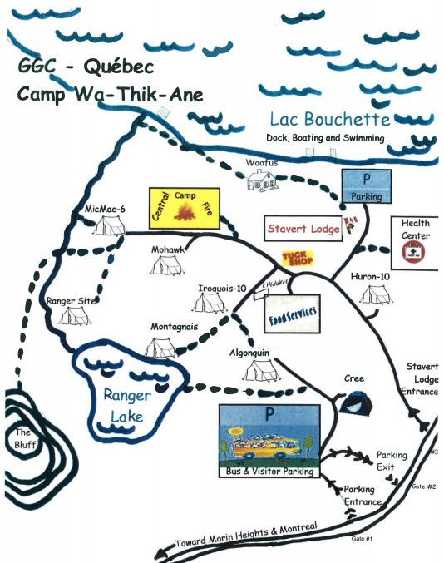
3
2
1
Parking 1 & 2 Closed after snow accumulation!
Bus Turnaround
Overflow Parking
Winter Leader Parking

Camp Wa-Thik-Ane Reservation Form Winter 2019-2020 for Non-Members

Unit/Group name: Number of campers:

Responsible Adult’s name:

Responsible Adult’s e-mail Phone:

Dates requested
Date
Choice #1
Choice #2
Choice #3

Stavert Lodge rental cost ($920 + taxes = $1057.77): | $
Daycamp cost ($11.50 + taxes = $13.23 per person) | $
Outdoor camper cost ($11.50 + taxes = $13.23 per person per night) | $
TOTAL CAMP FEES due | $
Non-refundable deposit (25% due with reservation) | $
Balance due (total fees less deposit) due 2 weeks prior to camp.
A detailed invoice including taxes will be provided.
Damage/cleaning deposit (separate cheque, please) $150 per site due with reservation | $150.00

Payment may be made with cheque, certified cheque, money order, MasterCard or Visa. There will be a $30.00 fee for all NSF cheques. Please make cheque payable to GGC-Québec Council.

☐ I have read the reservation information document, including the terms of payment and the cancellation policy

Responsible Adult’s name Today’s Date (mm/dd/yyyy) / /

e-mail this sheet only to qc-admin@guidescanada.ca, or mail to:
WTA Reservations – GGC Québec Council
270-100 boul. Alexis Nihon
Saint-Laurent QC H4M 2N7

* * * * * * * * * * * * * * * * * * * * * * * * * * * * * * * * * * * * * * * * * * * * * * * * * * * * * * * * * * * * * * * * * * * * * * * * * * * * * * *
For office use

Deposit □cheque □Credit Card Credit Card # ___________________________ Expiry Date _____/_____
Name on Card___________________________ CVV: _______ (mm/yy)

Balance □cheque □Credit Card Credit Card # ___________________________ Expiry Date _____/_____
Name on Card___________________________ CVV: _______ (mm/yy)

□ Damage/cleaning deposit received

