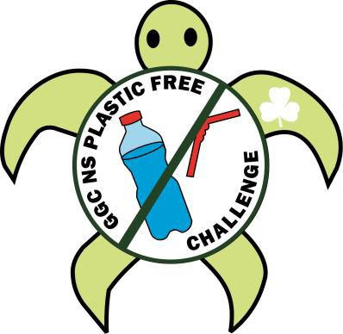

Plastic Free Challenge - Crest Order Form

Send the completed form along with the payment for the crests to:
Girl Guides of Canada – Nova Scotia Council, 3581 Dutch Village Rd., Halifax, NS B3N 2S9
Payment Options:
- Cheques / Money Order made payable to Girl Guides of Canada.
- Cash/Debit **NEW** at the Provincial Office.
- ** NEW** Visa / Mastercard- once order form has been sent, you can call the office to provide payment information.
Email Applications to : ns-ggc@girlguides.ca

Mail: ____________________ or Pick Up: ____________________

Contact Guider:
Unit:
District / Area:
Email Address:
Mailing Address:
Postal Code: |  | Phone Number:
Number of crests
 | Number of Crests: @ $2.00 each = (total)

We would love to see and hear about how you completed the challenge.
Email us at Program@girlguides.ns.ca

