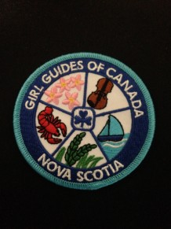 | NS PROVINCIAL CREST  Order Form

Send order form to: ns-ggc@girlguides.ca
Payment Options:
- Cash/Debit at the Provincial Office.
- ** Visa / Mastercard- once order form has been sent, please call the office to complete your payment.
Mail: ____________________ or Pick Up: ____________________

Contact Guider:
Unit:
District / Area:
Email Address:
Mailing Address:
Postal Code: |  | Phone Number:
Number of crests
Number of Crests: |  | @ $1.00 each | = | (total)

(Tax and Postage is included )

