Girl Guides of Nova Scotia Area/District Council Application

Contact Information
Name
Address
City/Town
Postal Code
Membership ID (IMIS)
Area
District
Unit Name
Primary Phone Number
E-Mail Address

Guiding Level for Fall 2019
. 3rd Year Pathfinder 3rd Year Ranger
. 1st Year Ranger Trex Member (Age 14-17 at the beginning of their terms)
. 2nd Year Ranger

Thank you for expressing an interest in joining your Area or District Council. As a member of council, your role would be to regularly attend council meetings (a minimum of four meetings a year) to represent youth in your region. Your role could involve managing area/district social media, helping organize area/district events, and more.

What is the difference between Area and District Council?
The province of Nova Scotia is currently divided up into six different Guiding Areas (pictured below). Each Area is led by a dedicated volunteer called the Area Commissioner who presides over the Area Council which consists of District Commissioners who represents the communities within the Area.

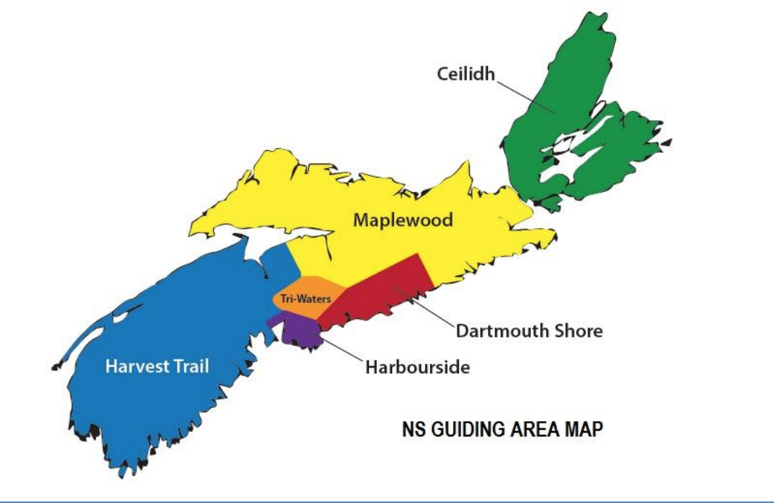
Provincial Commissioner —> Area Commissioner —> District Commissioner

The District Commissioner is chair of the District Council which consists of several communities within the Area. Both District and Area Council meet at least four times a year to discuss topics such as cookies, events, service projects, and more.

Example: Coastal District consists of the communities of Glace Bay, New Waterford, Dominion, Donkin, and Port Morien. Coastal District is a part of Ceilidh Area (Cape Breton).

Questionnaire

- Are you interested in joining your Area Council or District Council?
☐ AREA COUNCIL
☐ DISTRICT COUNCIL

- Why are you interested in joining an Area/District Council?

- What previous experience do you have that would make you a great fit for this role?

- What awards/achievements have you received outside of Guiding? (I.e. Academic Honour list, community service award). What kind of volunteering experience do you have?

- Why do you think it is important to have a youth representative on Area/District Council?

- Would you be interested in having a Guider mentor you throughout this process? If you have already been a member of a council or board outside of Guiding you may not need this additional mentorship.
☐ YES
☐ NO

- Is there anything else you would like to share to support your application?

