Dear Parent or Legal Guardian

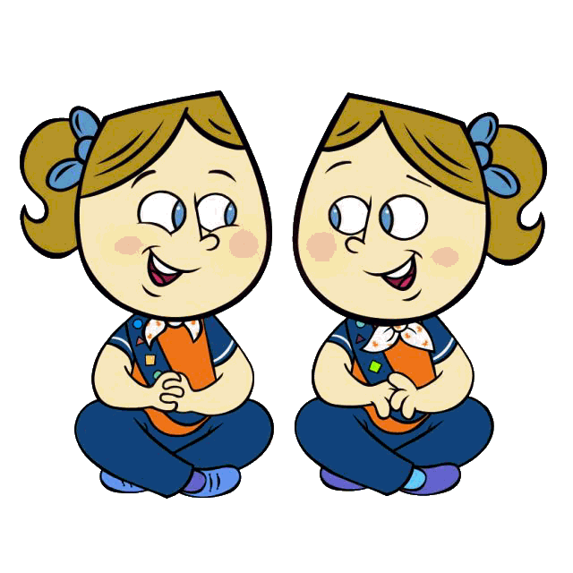When your daughter starts school in September she will be the right age to join a group of 7 and 8 year olds know as Brownies, a branch of Girl Guides of Canada-Guides du Canada. The hands-on program introduces girls to a wide variety of activities and allows them to try new things, make new friends, explore the world around them, gaining new skills and experiences in a safe, inclusive and accepting environment.

In Brownies, the girls gain confidence by learning skills they can use in their daily lives, everything from safety and environmental awareness to the importance of healthy choices. They will develop a commitment to their communities through service projects and special events.

Some activities might include:
- Camping, hiking and nature activities
- Community services projects
- Celebrating different cultures
- Finding out how to use basic tools, like screwdrivers and hammers
- Planning menus for healthy eating
- Visiting an artist’s studio
- Planting an edible garden
- Pursuing a special interest badge such as photography or event planning

No two Brownie meetings are alike!

Brownies work on exciting badges, go camping, visit interesting place and have fun! Meetings are usually once a week. The girls wear a uniform and earn badges.

To register go to our National website at www.girlguides.ca and click on Join Us. The Unit Finder will help you to find a group near you. If you need a paper application or wish to know more about Brownies, becoming a leader, or another branch of Guiding, please call or e-mail our Provincial Office and we will be pleased to assist you. Membership in our organization is open to adult females and girls over the age of five years. Come join us!

Contact: 1-800-565-8111
E-mail: info@bc-girlguides.org
Website: www.bc-girlguides.org

Girl Greatness Starts Here

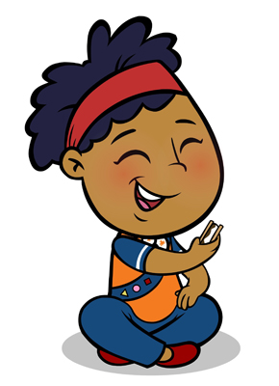
Girl Guides of Canada-Guides du Canada
Information for girls age 7 and 8
Grade two and three
Brownies
Call 1-800-565-8111
Girl Greatness starts here

